How to Capture Electronic Log Sheet (ELS)
Click on Trip Authority
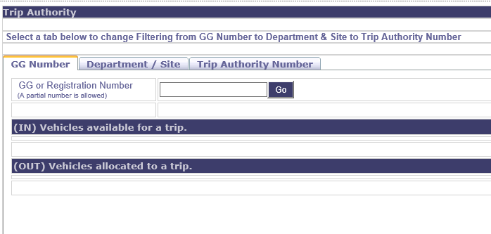
The System will show fig 1.
- GG Number Tab: This tab is used to search for the vehicle trip status using GG or GP Number (Trip either open or closed)
- Department / Site Tab: This tab is used when opening or closing a trip authority of vehicles registered for ELS under your Department-Site
- Trip Authority Number Tab: This tab is used to search for opened trip authority using Trip Authority Number
GG Number Tab
Type in the vehicle registration number you would like to search
Fig 2.
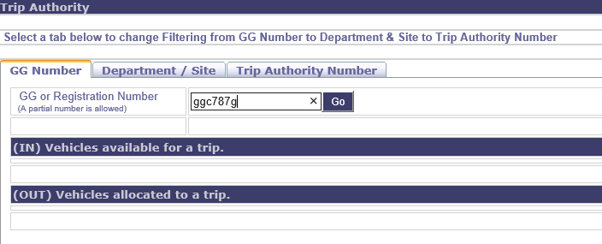
Outcome of search on two vehicles registration number used
Fig3: The vehicle with closed trip authority and available for opening a new trip authority by means of clicking on registration number
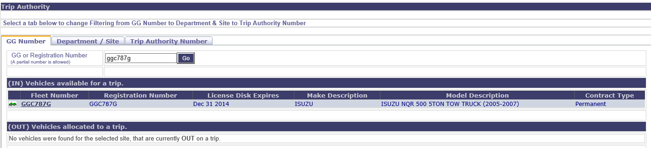
Fig4: The vehicle with opened trip authority “Vehicle in use status”. Trip authority can closed using this page by means of clicking on registration number
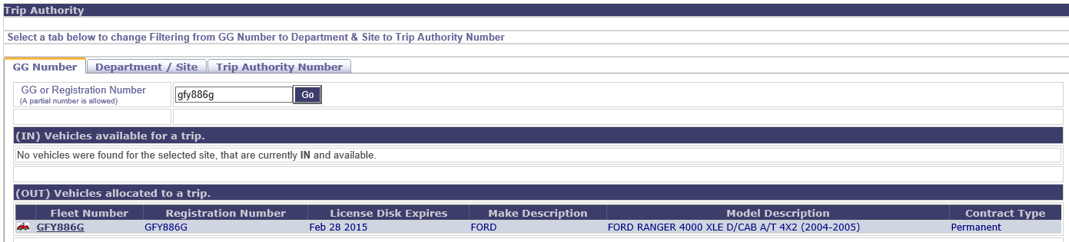
Department / Site Tab
Fig 5.
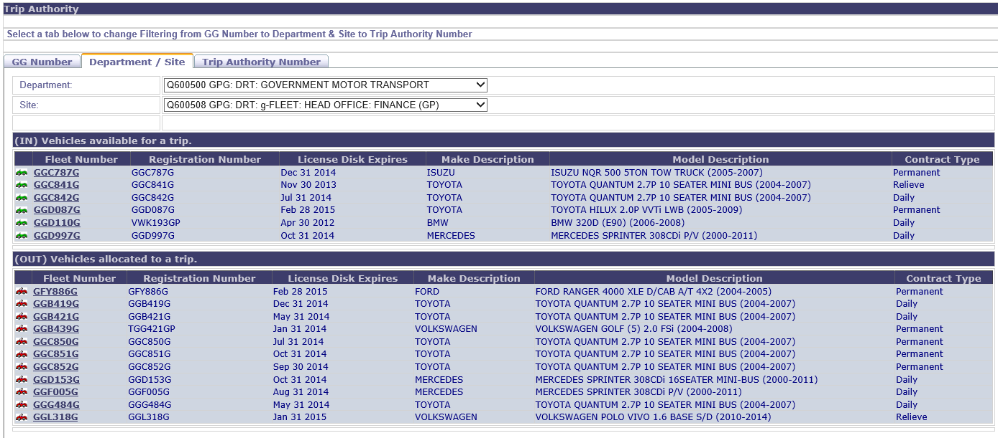

To open a trip authority for a vehicle, click on a vehicle registration number in the an (IN) Vehicle available for a trip list
Fig 6. This is the page that will displace for capturing trip request details
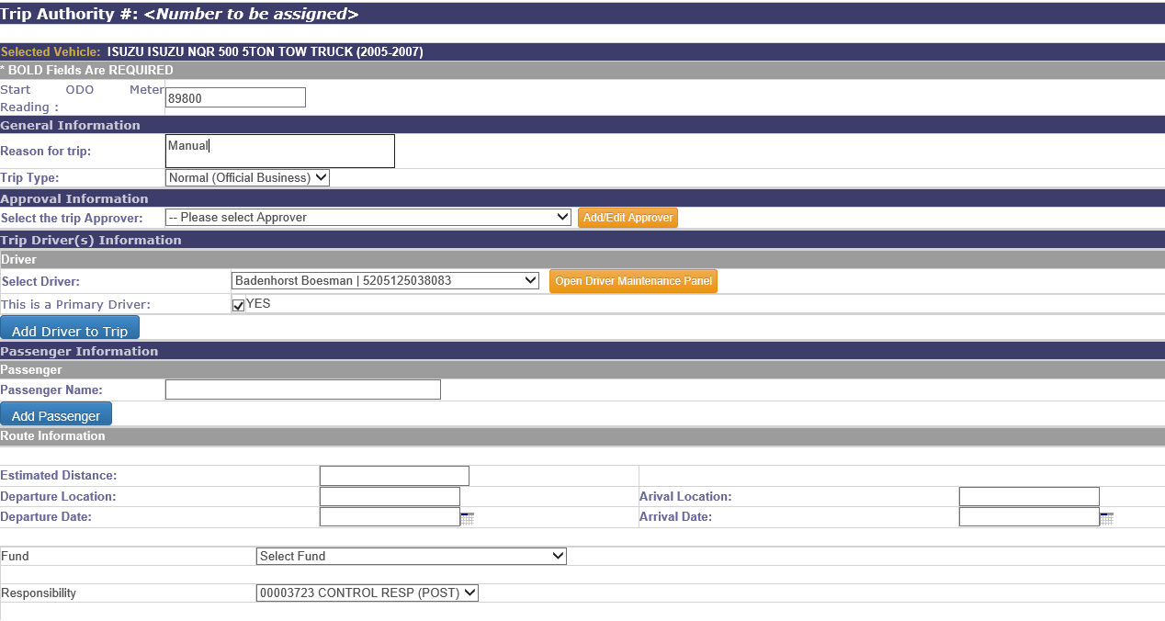
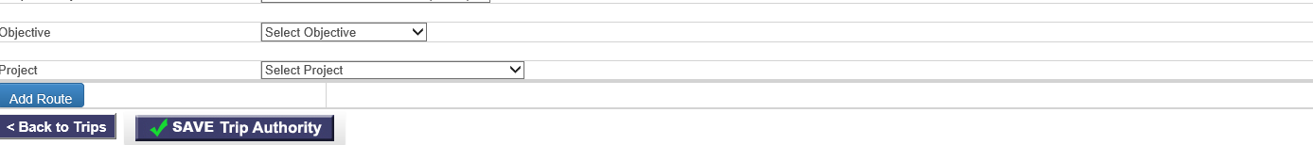
If Driver license has expired use Driver Maintenance Panel to amend and align driver information. Fig 6 is the page that will be opened for amending and aligning the details
Fig 6
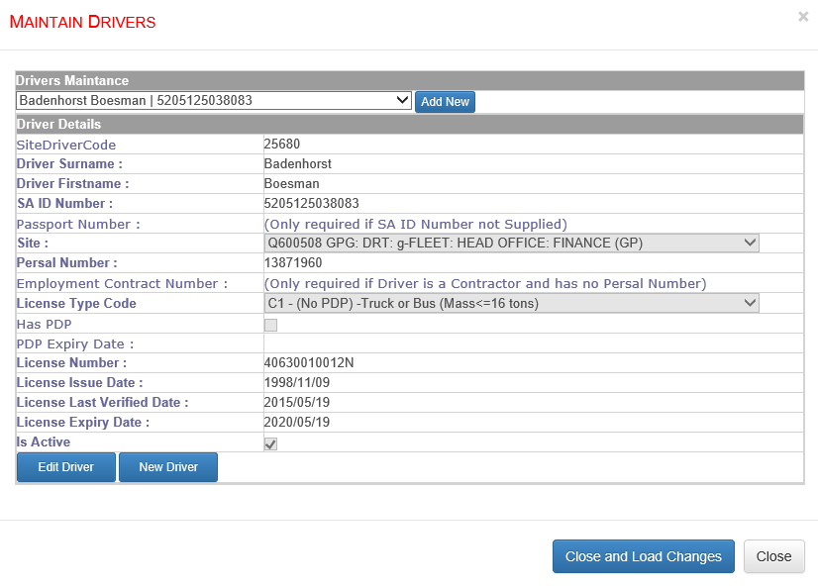
To close a trip authority for a vehicle, click on a vehicle registration number in the an (OUT) Vehicle available for a trip list

Fig 7. This page is used to closed an existing trip
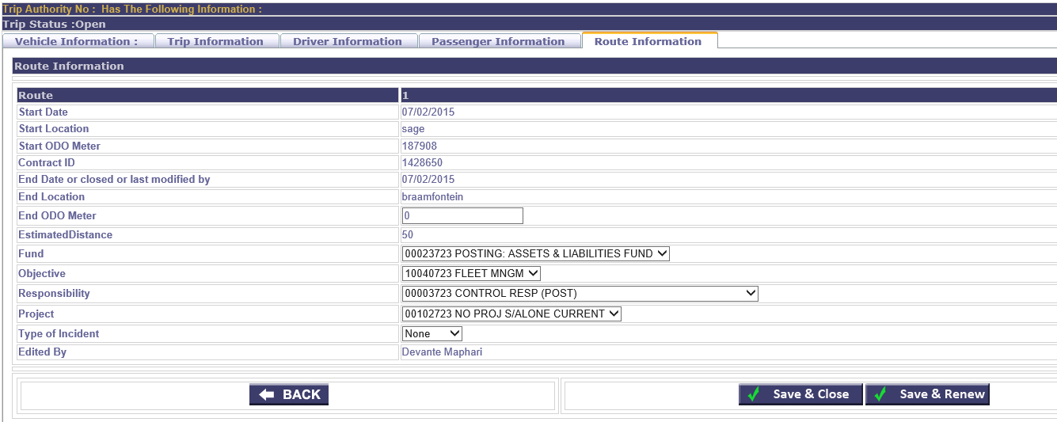
Trip Authority Number Tab
Fig 8. Type in the trip authority number of the existing trip issued for trip authority reprint or closure
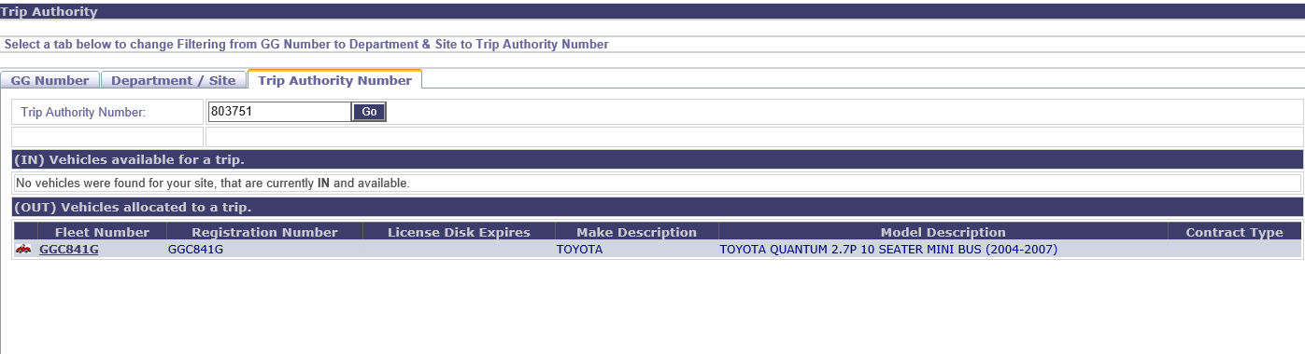
It must be noted that trip authority cannot be opened or closed if financial codes are not active for the site. Trip Authority must be opened and be closed within the same month for aligned and proper invoicing. ELS is the best way of managing km invoicing for all GG-vehicles

